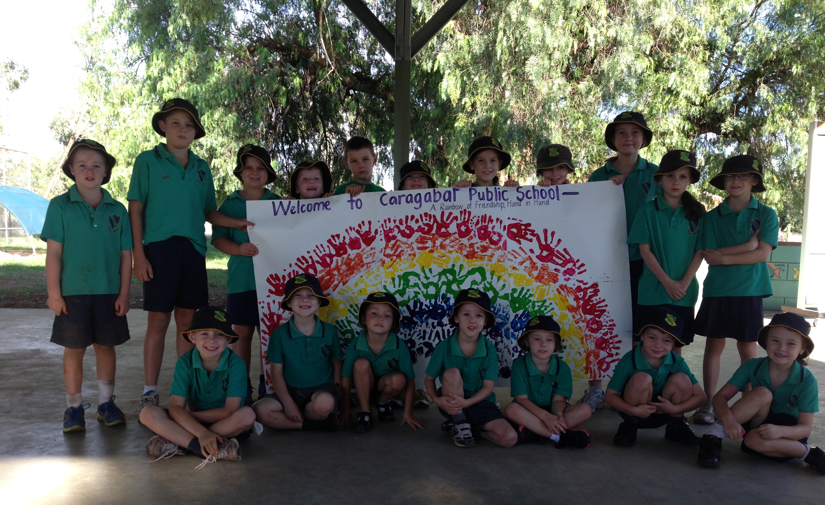

CARAGABAL PUBLIC SCHOOL 1503
School vision statement |  | School context |  | School planning process
Caragabal Public School encourages all students to achieve their goals through  - Extra opportunities to learn  - Persistence and responsibility  in an environment that is safe, fun and healthy resulting in socially confident students who are resilient, proud and equipped for the 21st Century. |  | Caragabal Public School is a small, rural school located within the village of Caragabal and continues to receive support from community members. Caragabal Public School provides a quality education, which caters for students in the Kindergarten to Year 6 setting. It offers all students a broad range of educational opportunities and the small student population ensures each student receives a high degree of individual attention. The school ensures a safe, caring and positive learning environment, which caters for the individual needs of the students. It endeavours to produce confident, well-educated students who have the ability to make positive contributions to society. Caragabal Public School has a strong focus on quality teaching and learning. The well-resourced school supports productive learning within an advanced technological classroom. The school's programs for students in Kindergarten to Year 6 classrooms are individual and varied according to their needs and learning styles. The school community is active, highly supportive and strongly committed to Caragabal Public School. |  | In 2014, the school sought the opinions of staff, students, parents and the community about the future directions of the school. Parents were surveyed about what skills they want their child to have when leaving the school. A meeting was then set up where at least one member of each family was represented. At this meeting, parents worked in small groups brainstorming ideas of our school strengths and areas of development in 3 areas: School Culture, Community Engagement and Student Learning.  When all of these ideas were tallied up, the top 3 responses became our priority areas.  Constant consultation at each stage of the planning process was done with the whole P&C or at least a P&C representative.

STRATEGIC DIRECTION 1  Successful Learners |  | STRATEGIC DIRECTION 2  Quality Educatuonal Programs |  | STRATEGIC DIRECTION 3  Community Engagement
To ensure students are resilient, socially confident, proud and equipped for the 21st Century. |  | Develop quality educational practices that incorporate syllabus standards and 21st Century skills resulting in improved student learning. |  | To develop a culture of high expectations and community engagement resulting in sustained and measureable whole-school improvement.

Strategic Direction 1: Successful Learners

Purpose |  | People |  | Processes |  | Products and Practices
To ensure students are resilient, socially confident, proud and equipped for the 21st Century. |  | Students: Students level of achievement will improve through the development of individualised plans and their knowledge of their own learning.  Parents: Develop capacity of Parents to actively engage in student learning.  Staff: All staff have a growth mindset. |  | - To develop Personalised Learning Plans with students and parents that explicitly cater for their educational needs around 21st Century learning and developing resilience.  - Develop structures to engage parents in their children’s learning, including parent forums around the new BOSTES syllabus implementation.  - Teachers regularly review student learning with each student, ensuring all students have a clear understanding of how to improve their learning and communicate this to parents . |  | Products  - 100% of students Personalised learning plan developed and documented.  - Students to meet the state benchmarks in reading from 50% in 2015 to 75% in 2017.  Practices  - Teachers and students are engaged and contributing to personalised learning plans  - Use PLAN and NAPLAN results and standardised classroom assessment for future planning.  - Continuous and effective assessment and reporting driven by individual learning.
Improvement Measures
- 100% of students Personalised learning plan developed and documented in PLAN.

- Students to meet the state benchmarks in reading from 50% in 2015 to 75% in 2017.

Strategic Direction 2: Quality Educational Programs

Purpose |  | People |  | Processes |  | Products and Practices
Develop quality educational practices that incorporate syllabus standards and 21st Century skills resulting in improved student learning. |  | Staff: Staff have the ability to implement high Quality Teaching programs.  Parents: Parents gain knowledge of the implementation of the Board of Studies curriculum.  Staff: Staff will have a Professional Learning Plan designed explicitly around teacher professional needs to provide innovative teaching and learning strategies that reflect the implementation of the Board of Studies syllabi. |  | - Develop a K-10 Literacy and Numeracy Scope and Sequence and an assessment schedule with our learning community partners.  - Engage staff in training of new BOS syllabus implementation and National Teaching Standards and develop individual Professional Learning Plans to explicitly target teacher capacity.  - Structures to interact amongst staff from the Weddin Learning Community. |  | Products  - 100% of staff have a Professional Learning Plan explicitly targeted towards professional learning needs.  - Literacy and Numeracy continuums are used to inform Teaching and Learning  - Board of Studies Syllabi are embedded into class programs.  - Weddin Learning community has developed and are implementing Scope and Sequence as evidenced in Teaching and Learning programs.  Practices  - Teaching and Learning programs reflect innovative practices and 21st Century Learning skills.
Improvement Measures
- Literacy and Numeracy continuums are used to inform Teaching and Learning.

- BOS Syllabi are embedded into class programs.

Strategic Direction 3: Community Engagement

Purpose |  | People |  | Processes |  | Products and Practices
To develop a culture of high expectations and community engagement resulting in sustained and measureable whole-school improvement. |  | Staff: Provide opportunities for students to interact meaningfully in their community.  Learning Community: Weddin Learning Community consisting of The Henry Lawson High School, Grenfell Public School Quandialla Central School work collaboratively together to improve student outcome.  Community Partners: Community partners will extend their community projects to include the school, offering and asking for support.  Parents: Parents will support the opportunities provided by the school and community organisations to enhance student involvement.  Students: Will have a community based attitude which extends beyond the classroom and Year 6. |  | - Seek out and invite in community groups to offer assistance and support and develop a plan to become involved in community organisations and event.  - Survey students pre and post in relation to community involvement.  - Structures to interact amongst staff from the Weddin Learning Community. |  | Products  - Students initiate, plan and implement community based projects that support and enhance the local area.  - Students have an appreciation and respect for community celebrations and events.  - Students have a greater understanding of local organisations, how they operate and are willing to support their community.  Practices  - Staff expose students to local, national and world issues.  - Students show confidence in interacting with local community members.  - Staff and students become actively involved in regular community projects.  - Students and staff will engage in local events.
Improvement Measures
- Students initiate, plan and implement community based projects that support and enhance the local area
- Students have a greater understanding of local organisations, how they operate and are willing to support their community

